Part 1
- The diameter of an atom is about 0.000 000 000 2 m. What is this distance in standard form?
- What is the nucleus of an atom composed of?
- Describe what happens when an electron drops to a lower energy level in an atom.
- An atom of sodium is represented by:
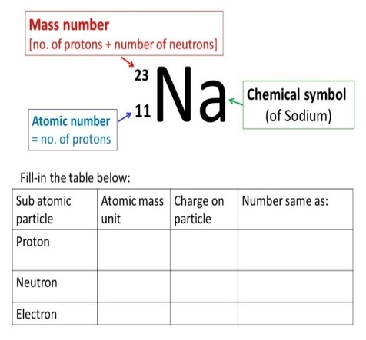
Use this information to determine the number of protons, neutrons and electrons in an atom of sodium.
- What is the electrical charge attached to:
a neutron
an electron
a proton
- What is the mass number and the atomic number for fluorine?
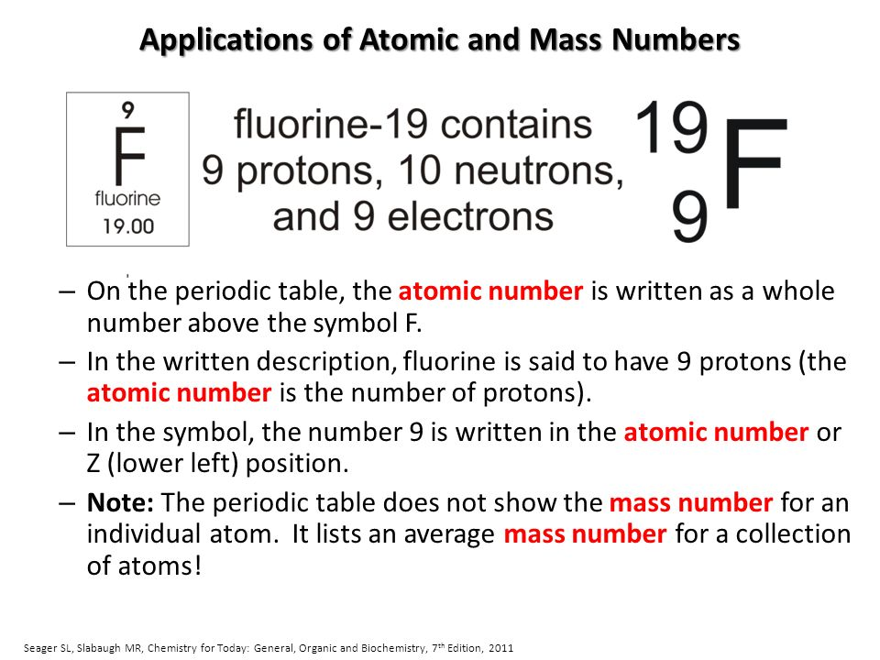
- Beryllium has the chemical symbol:
Use this information to draw a representation of an atom of beryllium.
- A different isotope of beryllium has an extra neutron. Give the chemical symbol of this new isotope of beryllium.

- The radioactive element Uranium has two common isotopes.
Complete the table to show the number of protons, neutrons and electrons in each isotope.
- Sodium can lose its outer electron to have a full outer energy level. What will the atom now become?

- Which part of an atom is involved with radioactive decay?

- Explain the meaning of the term activity, as applied to radioactive materials and state the units of activity.

- What is meant by the term “count rate”?

- Copy and complete the table to show the nature of alpha, beta and gamma radiations.

- A piece of radioactive rock shows a reading of 350 counts/min. When covered in aluminium foil, this drops down to 4 counts/min. Explain which type of radiation this rock is emitting.

- Radioactive emissions are often described as ionising radiations. What does this mean?

- Smoke detectors use americium-241 which is an alpha emitter. Explain why an alpha source is used in these detectors.

- Why is an alpha particle often described as a helium nuclei?
Part 2
- Complete the nuclear equation for the beta decay of carbon
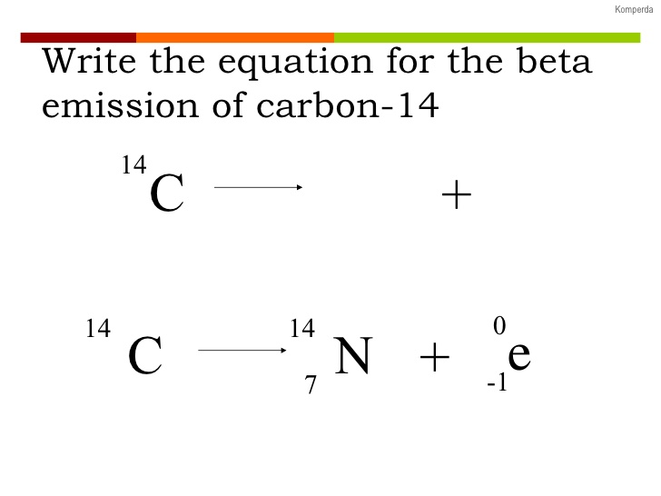

- Uranium-235 undergoes an alpha decay to produce thorium-231. (atomic number of Uranium is 92). Complete the nuclear equation for this process.

- When iodine 131 decays, there is no mass change in the nucleus and no new products formed. What type of radioactive emission is this?

- Explain what is meant by the term “half-life”.

- A radioactive sample reduces its count rate from 240 counts/min to 30 counts/min over a period of 60 hours what is its half-life?
- Use the decay curve below to work out the half-life of the isotope.
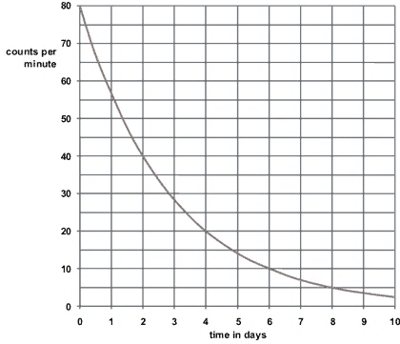
- Calculate the net decline of the above isotope expressed as a ratio, during radioactive emission after 3 half-lives.

- Explain the difference between radioactive irradiation and radioactive contamination.

- Copy and complete the table below to suggest one way of preventing exposure to irradiation and contamination by radioactive materials.

- Radium - 226 is an alpha emitter with a half-life of 1600 years. Explain how the way this material is stored is influenced by these properties.

- The diagram shows how three separate gamma beams are used to treat a cancer tumour. Why is this preferred to using one powerful beam?
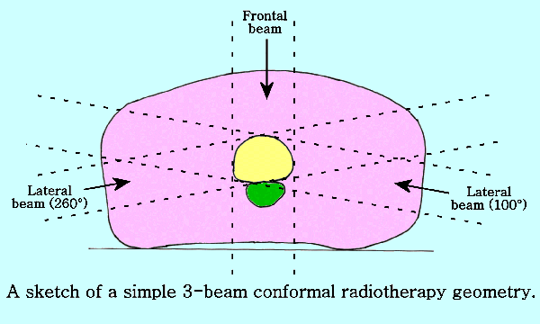
- Alpha emitting radioisotopes cannot be used as tracers in the body to explore injured or diseased organs. Why?
Part 3
- Which particle is needed to begin the fission of a large, unstable nuclei?

- During the fission of uranium, two smaller nuclei are produced and what else?

- Copy and complete the diagram below to show the chain reaction of a sample of uranium
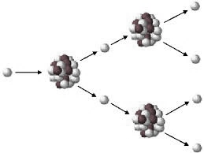
- Explain what is meant by a controlled chain reaction.
- What is nuclear fusion?
- Where does nuclear fusion take place on a large scale?
- Draw a diagram to show the process of fusion between deuterium and tritium to produce energy.

